SCHEMATIC OUTPUT

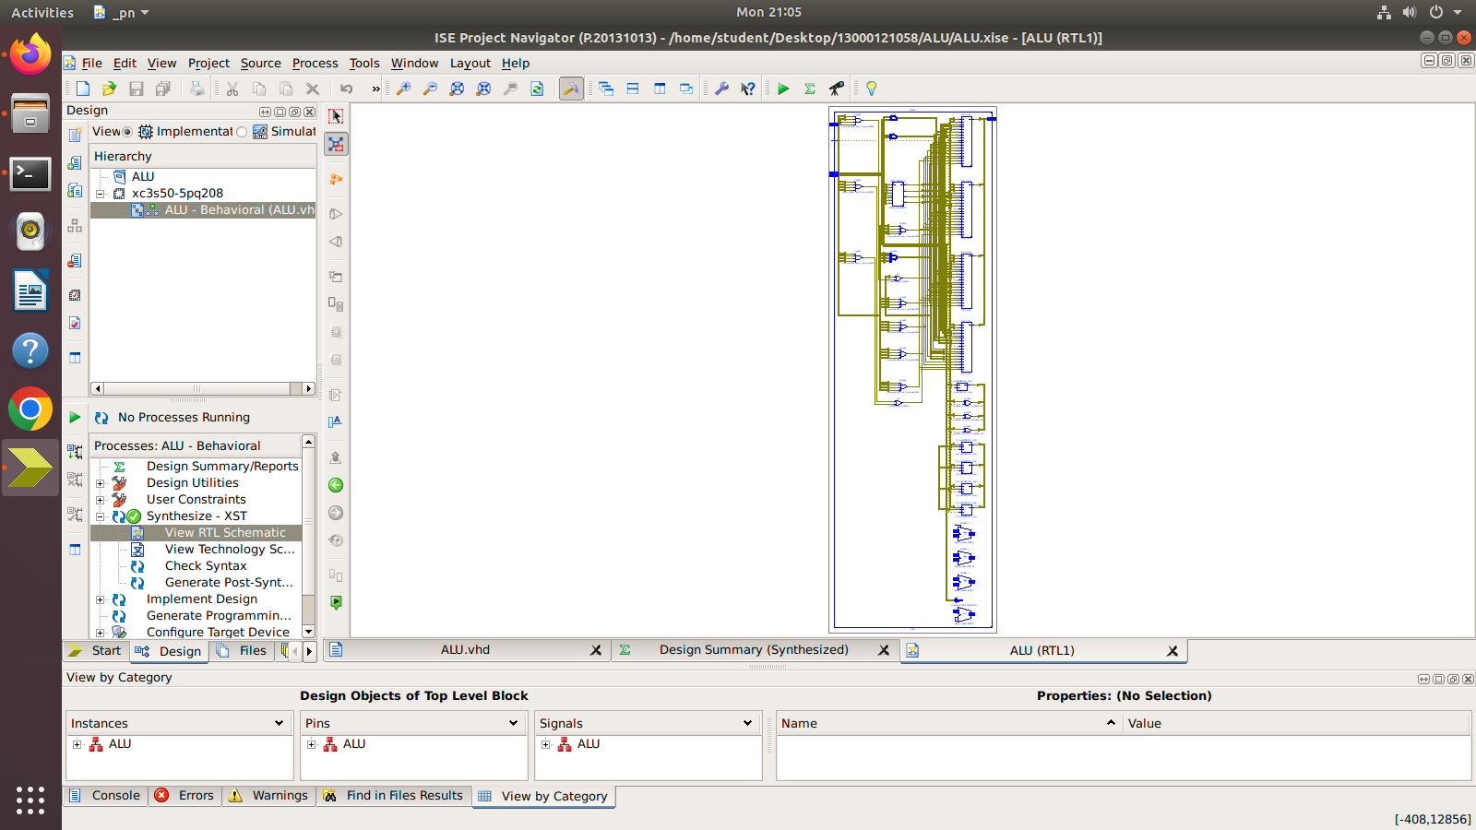

TEST OUTPUT

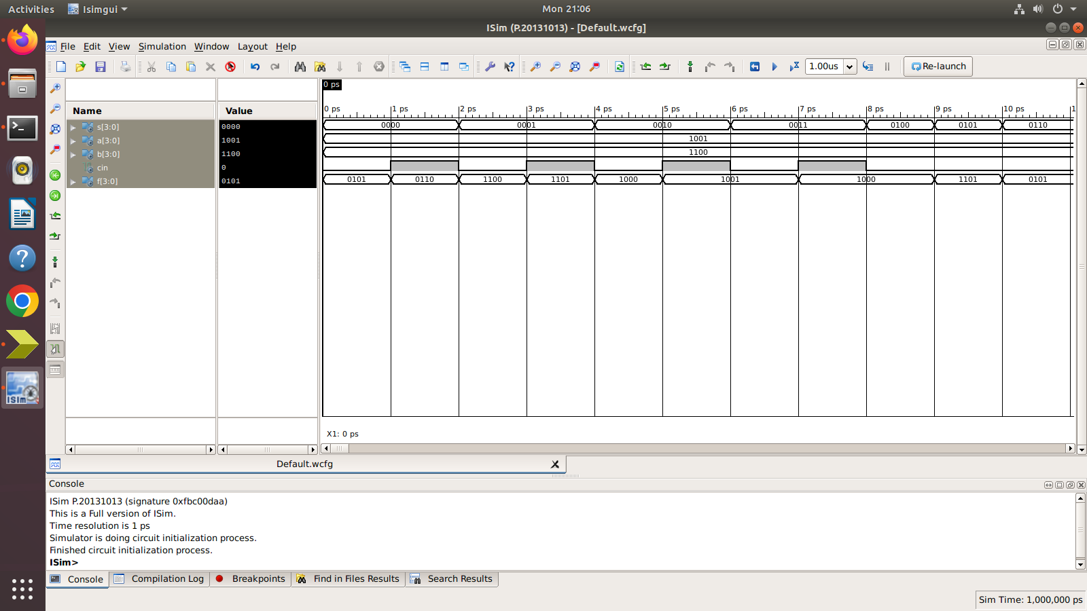

OUTPUT

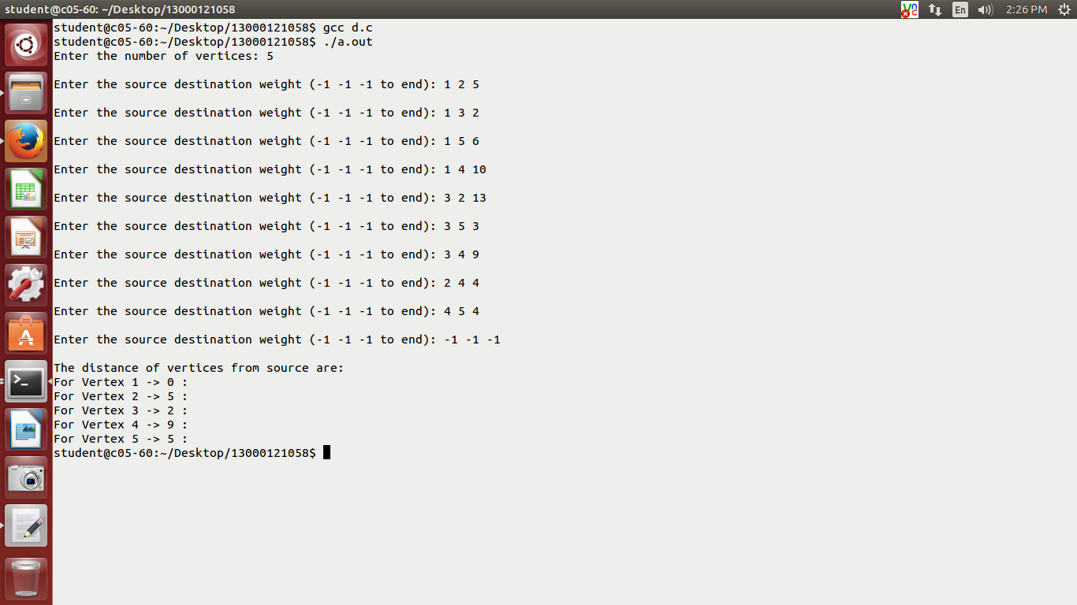
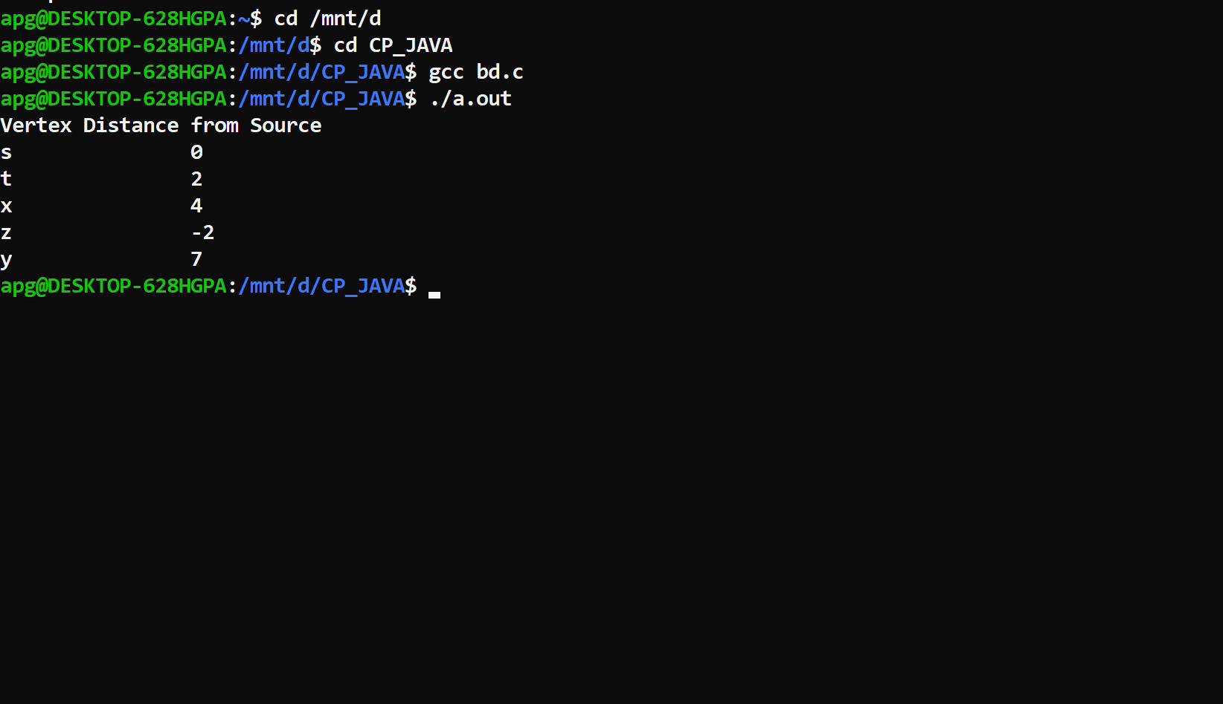

OUTPUT

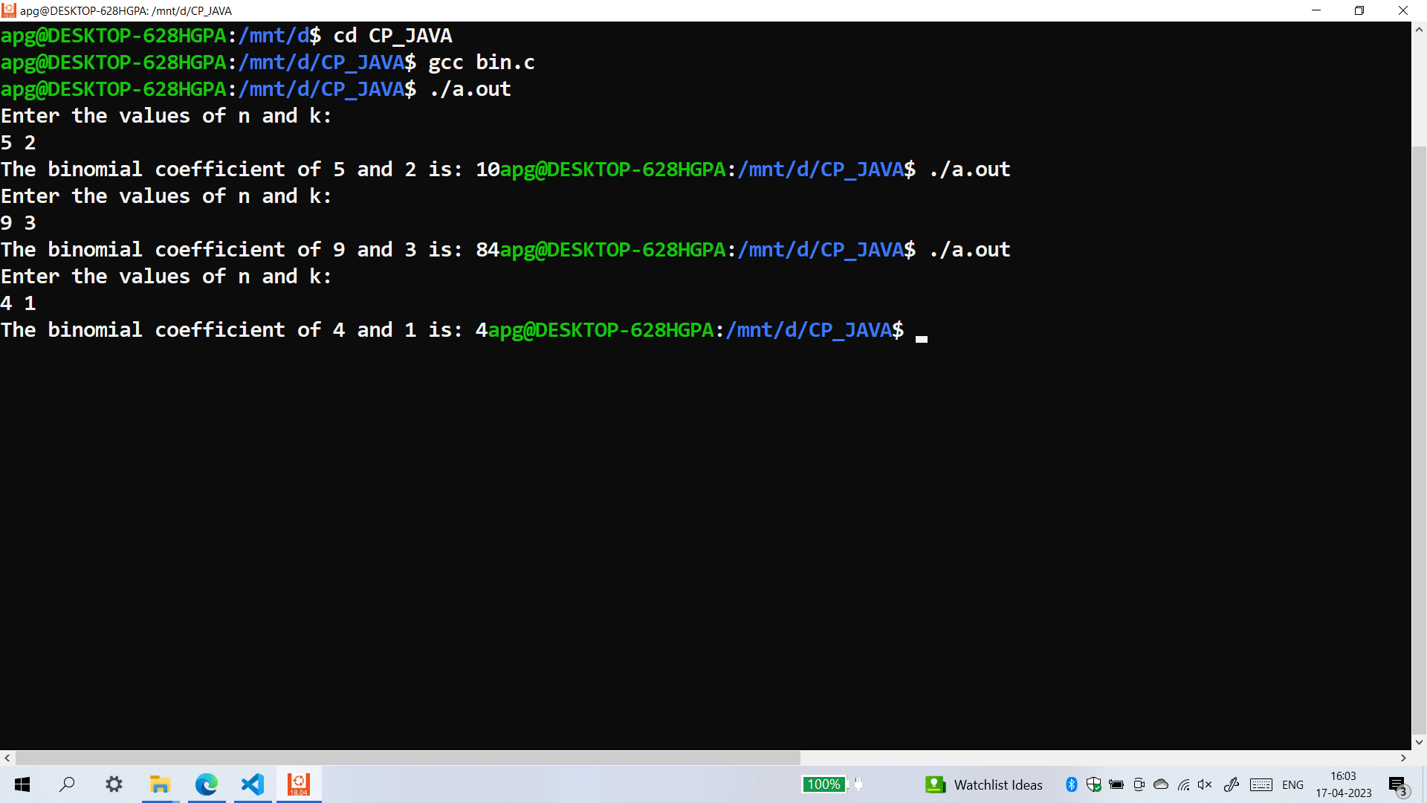

OUTPUT

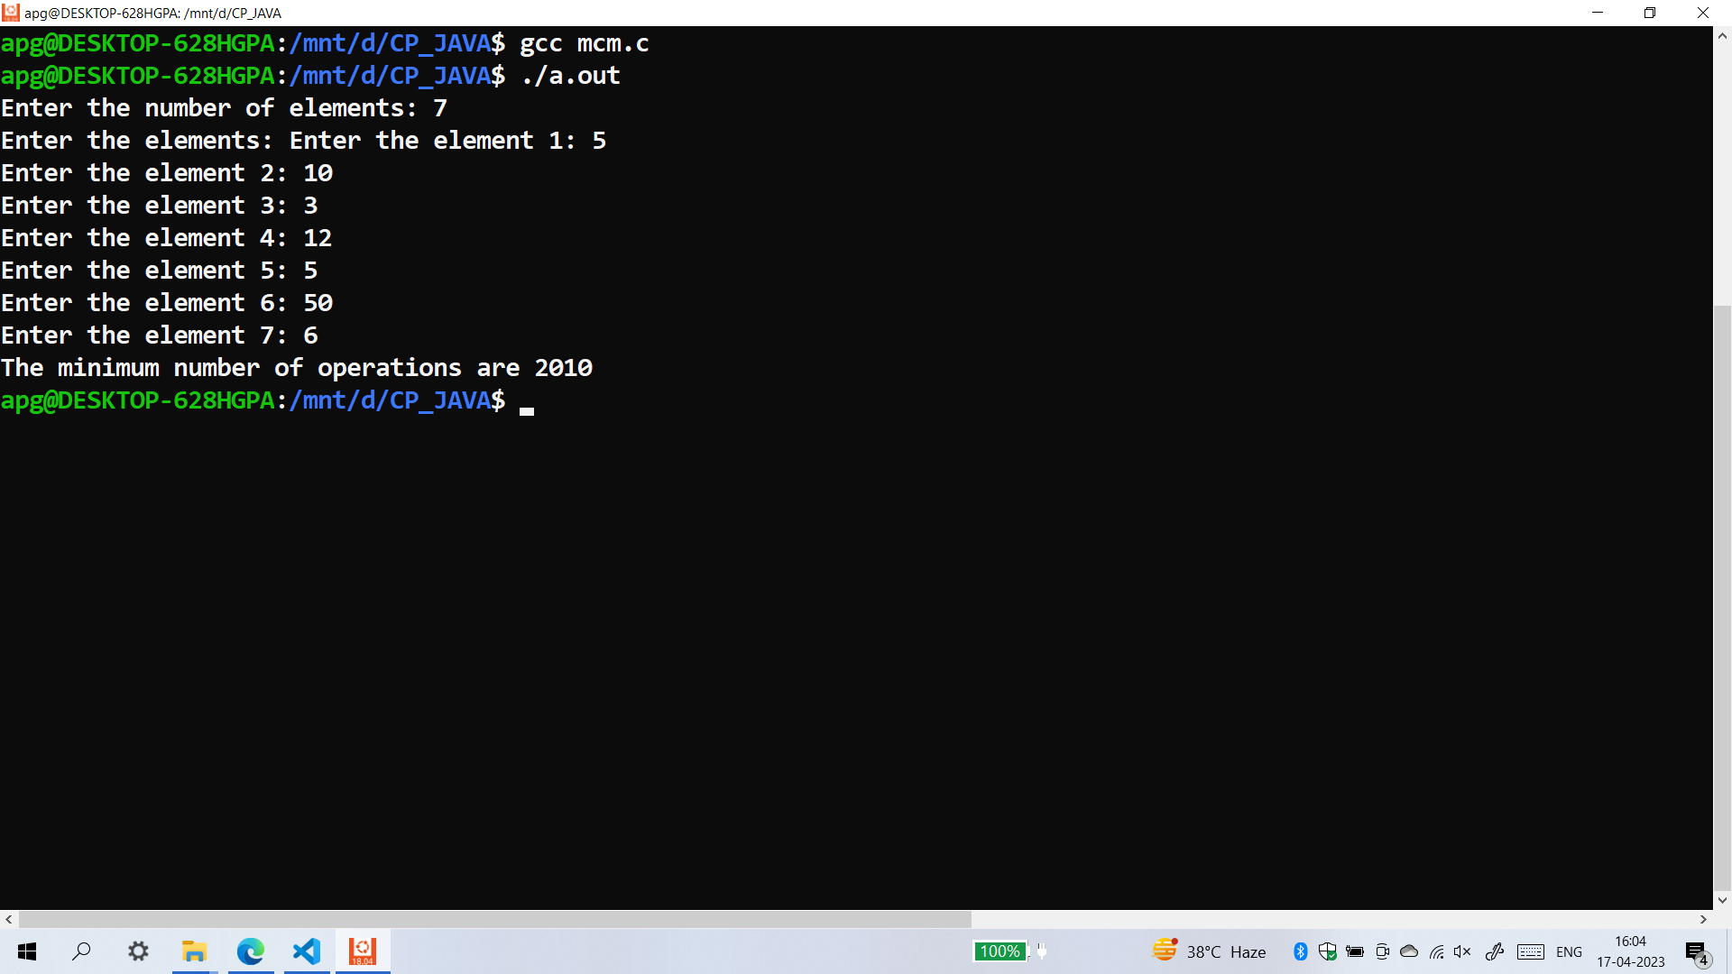

ASSIGNMENT 3.2
Find the minimum number of scalar multiplication needed for chain of matrix whose sequences are < 5, 10, 3, 12, 5, 50, 6 > using the dynamic programming technique.

FLOWCHART
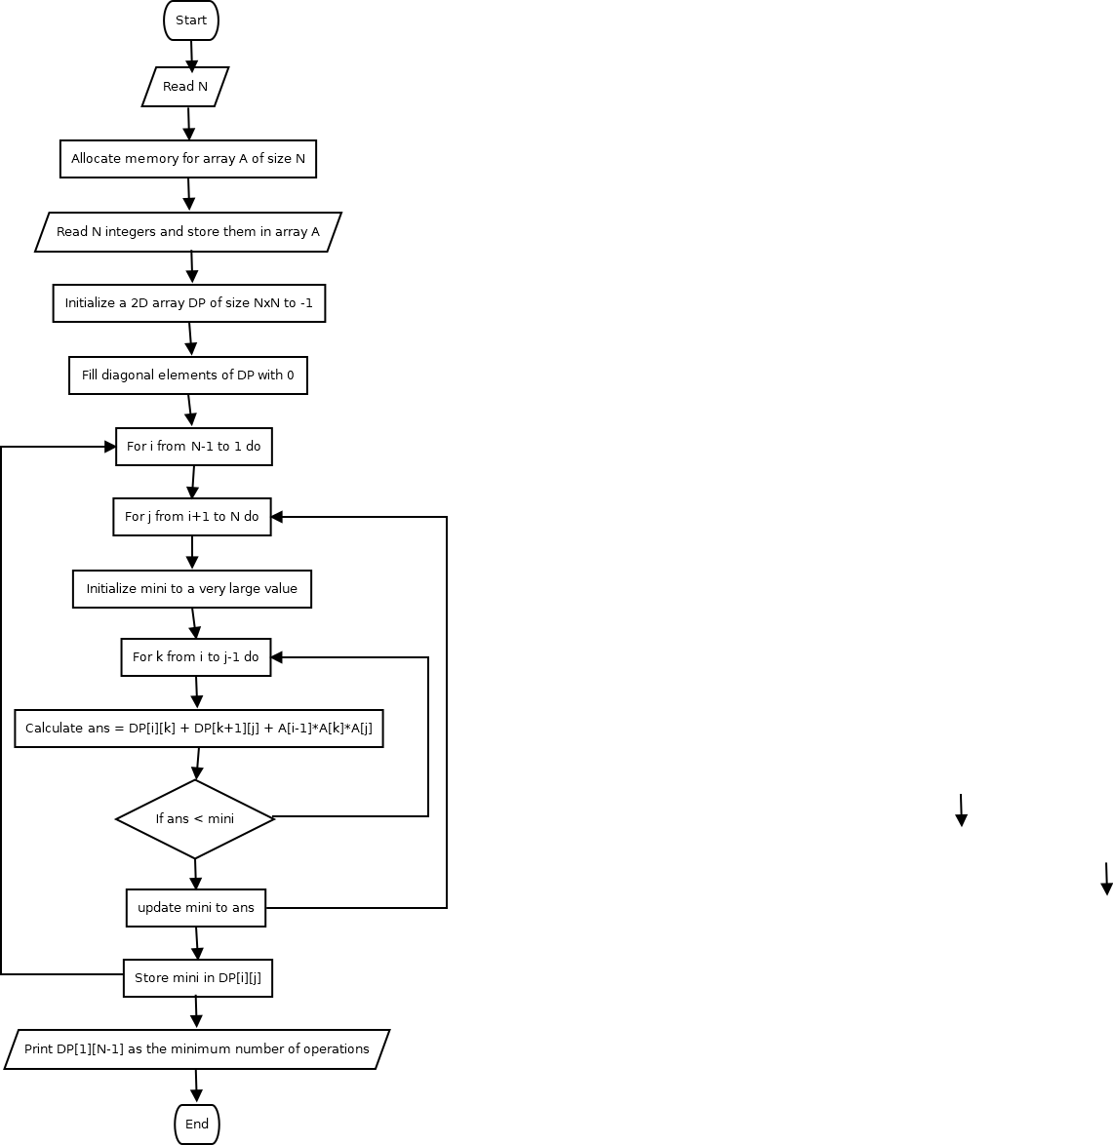

ASSIGNMENT 3.1
Write a program to find the binomial coefficient using Dynamic programming method.

FLOWCHART
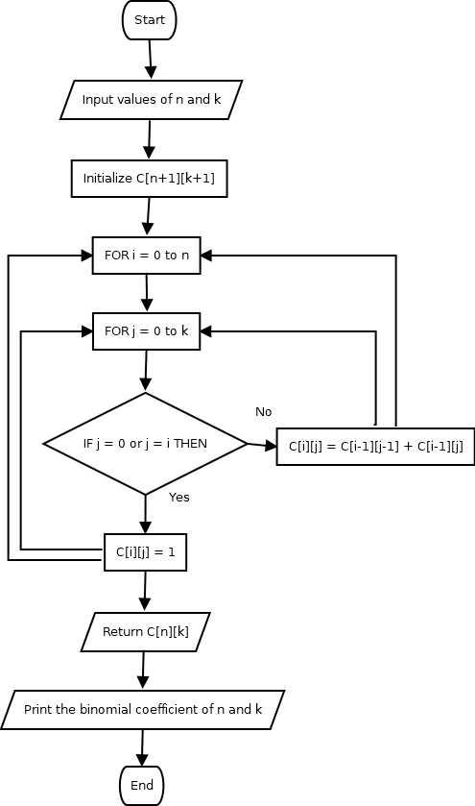

ASSIGNMENT 4.2
WAP using the single-source-shortest-path problem to find out the shortest path from the source vertex ‘s’ using the Bellman-Ford’s algorithm, using the dynamic programming technique.
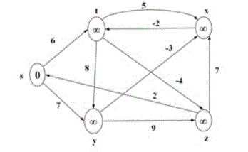

FLOWCHART
